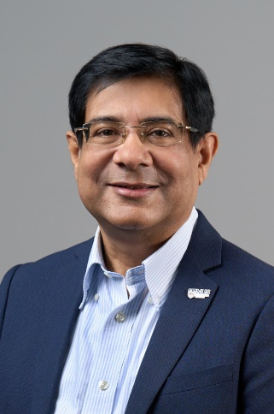
Sanjay SWARUP

Associate Professor
Contact Information:
Department of Biological Sciences
National University of Singapore
14 Science Drive 4
Singapore 117543
Lab: Sanjay Lab
Additional Affiliations:
Director, NUS Environmental Research Institute, National University of Singapore, #02-03, T-Labs 5A Engineering Drive 1, Singapore 117411
Director, Graduate Program | Singapore Centre for Environmental Life Sciences Engineering (SCELSE) | Nanyang Technological University | SBS-01n-15, 60 Nanyang Drive, Singapore 637551 | Tel: (65) 6316 2820 GMT+8h | Fax: (65) 6791 3856
Phone: 6516 7933
Fax : 6779 2486
Email : dbsss@nus.edu.sg / eridir@nus.edu.sg

CURRICULUM VITAE

Personal Details:
Name: Sanjay Swarup
Title: Associate Professor
Office Mailing Address: Department of Biological Sciences, National University of Singapore, Science Dr 4, Singapore 117 543
Email: sanjay@nus.edu.sg
Contact No.: +65 6516 7933, FAX: +65 6779 2486

Current Position/Affiliations:
Associate Professor (100% in Singapore)
Department of Biological Sciences
National University of Singapore
Singapore 117 543
Website: www.dbs.nus.edu.sg/staff/sanjay.htm

Director
NUS Environmental Research Institute
National University of Singapore
#02-03, T-Labs 5A Engineering Drive 1,
Singapore 117411
Website: www.nus.edu.sg/neri

Director, Graduate Program
Singapore Centre on Environmental Life Sciences
Nanyang Technological University
SBS-01n-15, 60 Nanyang Drive,
Singapore 637551
Website: www.scelse.sg

Employment history:
Associate Professor: 2004-present, National University of Singapore
Assistant Professor: 1998-2004, National University of Singapore
Senior Lecturer: 1997-1998, National University of Singapore
Lecturer: 1994-97, National University of Singapore
Postdoctoral Fellow: 1991-94, Waksman Institute, Rutgers University, USA

Academic qualifications:
Ph.D. 1991 Univ. of Florida, Gainesville, Florida. Plant Pathology.
Ph.D. 1990 Indian Agricultural Research Institute, New Delhi, INDIA. Genetics
M.Sc. 1985 Indian Agricultural Research Institute, New Delhi, INDIA. Genetics
B.Sc. (Ag.) Hons. 1983 Punjab Agricultural University, Ludhiana, Punjab, INDIA

Research interests:
My lab is involved in studying the ecology of mixed microbial communities in the environment and agriculture from genes to ecosystems level scales. Our focus is to determine mechanistic basis of ecosystem functioning especially the role of phytobiomes and microbiomes in order to provide transnational tools and explanations for policy and management decisions. We are taking a multidisciplinary approach by incorporating hydrology, robotics and AI, meta-genomics, metabolomics, computational, and high-resolution imaging to study these interesting biological systems. These programs are shaped by my training in field-based themes of plant breeding plant pathology combined with lab-based training in molecular biology.

